31 Ağu 2021

MATPLOTLIB

# **Intermediate(Customizing Figure Layouts)**

1. Basic kullanım

* [fig1](https://matplotlib.org/stable/api/figure_api.html#matplotlib.figure.Figure), [f1_axes](https://docs.scipy.org/doc/numpy/reference/generated/numpy.ndarray.html#numpy.ndarray) = [plt.subplots](https://matplotlib.org/stable/api/_as_gen/matplotlib.pyplot.subplots.html#matplotlib.pyplot.subplots)(ncols=2, nrows=2, constrained_layout=**True**) # 2x2’lik bir axes oluşturur.

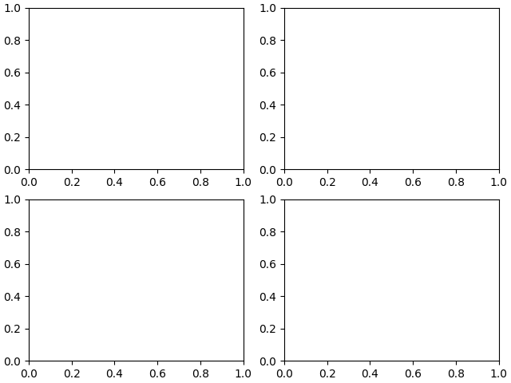

* GridSpec ile kullanımı
  + [fig2](https://matplotlib.org/stable/api/figure_api.html#matplotlib.figure.Figure) = [plt.figure](https://matplotlib.org/stable/api/_as_gen/matplotlib.pyplot.figure.html#matplotlib.pyplot.figure)(constrained_layout=**True**)

[spec2](https://matplotlib.org/stable/api/_as_gen/matplotlib.gridspec.GridSpec.html#matplotlib.gridspec.GridSpec) = [gridspec.GridSpec](https://matplotlib.org/stable/api/_as_gen/matplotlib.gridspec.GridSpec.html#matplotlib.gridspec.GridSpec)(ncols=2, nrows=2, figure=[fig2](https://matplotlib.org/stable/api/figure_api.html#matplotlib.figure.Figure))

Üzerine add_subplot ile matrix’e eleman eklemeleri yapılır.

1. GridSpec’te Ayarlamalar

* [fig8](https://matplotlib.org/stable/api/figure_api.html#matplotlib.figure.Figure) = [plt.figure](https://matplotlib.org/stable/api/_as_gen/matplotlib.pyplot.figure.html#matplotlib.pyplot.figure)(constrained_layout=**False**) #Figure doldurmayı kapatıp manuel ayarlama yapılır.

[gs1](https://matplotlib.org/stable/api/_as_gen/matplotlib.gridspec.GridSpec.html#matplotlib.gridspec.GridSpec) = [fig8.add_gridspec](https://matplotlib.org/stable/api/figure_api.html#matplotlib.figure.Figure.add_gridspec)(nrows=3, ncols=3, left=0.05, right=0.48, wspace=0.05) #Parametreler girilerek grafiğin Figure’ün nerede olacağını belirleriz.

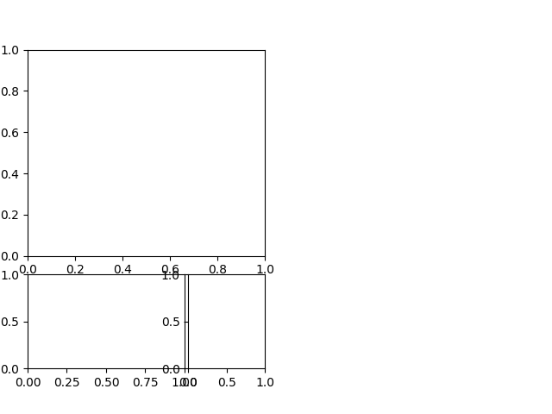

1. SubplotSpec’in GridSpec ile kullanılması

* İç içe bölünmüş grafikler ortaya çıkartabiliriz.

[fig10](https://matplotlib.org/stable/api/figure_api.html#matplotlib.figure.Figure) = [plt.figure](https://matplotlib.org/stable/api/_as_gen/matplotlib.pyplot.figure.html#matplotlib.pyplot.figure)(constrained_layout=**True**)

[gs0](https://matplotlib.org/stable/api/_as_gen/matplotlib.gridspec.GridSpec.html#matplotlib.gridspec.GridSpec) = [fig10.add_gridspec](https://matplotlib.org/stable/api/figure_api.html#matplotlib.figure.Figure.add_gridspec)(1, 2)

[gs00](https://matplotlib.org/stable/api/_as_gen/matplotlib.gridspec.GridSpecFromSubplotSpec.html#matplotlib.gridspec.GridSpecFromSubplotSpec) = [gs0](https://matplotlib.org/stable/api/_as_gen/matplotlib.gridspec.GridSpec.html#matplotlib.gridspec.GridSpec)[0].subgridspec(2, 3)

[gs01](https://matplotlib.org/stable/api/_as_gen/matplotlib.gridspec.GridSpecFromSubplotSpec.html#matplotlib.gridspec.GridSpecFromSubplotSpec) = [gs0](https://matplotlib.org/stable/api/_as_gen/matplotlib.gridspec.GridSpec.html#matplotlib.gridspec.GridSpec)[1].subgridspec(3, 2)

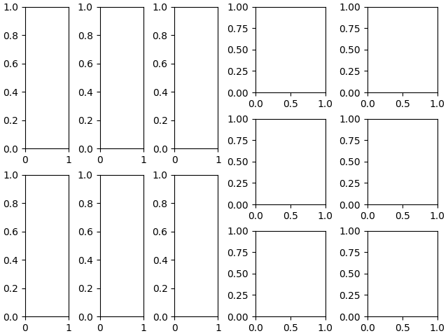

Referanslar:

https://matplotlib.org/stable/tutorials/intermediate/gridspec.html#sphx-glr-tutorials-intermediate-gridspec-py